[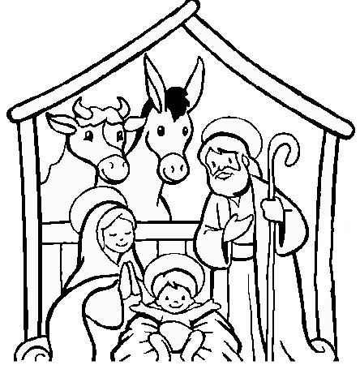](https://www.google.fr/url?sa=i&rct=j&q=&esrc=s&source=images&cd=&cad=rja&uact=8&ved=0ahUKEwjppsig9d7XAhVhKsAKHZqoCJAQjRwIBw&url=http://classedemyli.over-blog.com/2013/12/coloriage-sur-la-cr%C3%A8che-de-no%C3%ABl-l-enfant-j%C3%A9sus-la-nativit%C3%A9.html&psig=AOvVaw0oNPWx4usS5VlaZflp_vvc&ust=1511877642893077)

Quelques coloriages de crèche

[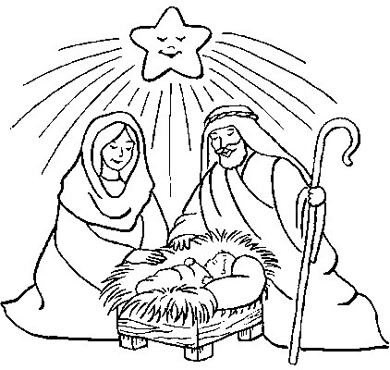](https://www.google.fr/url?sa=i&rct=j&q=&esrc=s&source=images&cd=&cad=rja&uact=8&ved=0ahUKEwjGvuKq9d7XAhXBDcAKHbZkBRUQjRwIBw&url=http://classedemyli.over-blog.com/2013/12/coloriage-sur-la-cr%C3%A8che-de-no%C3%ABl-l-enfant-j%C3%A9sus-la-nativit%C3%A9.html&psig=AOvVaw0oNPWx4usS5VlaZflp_vvc&ust=1511877642893077)

[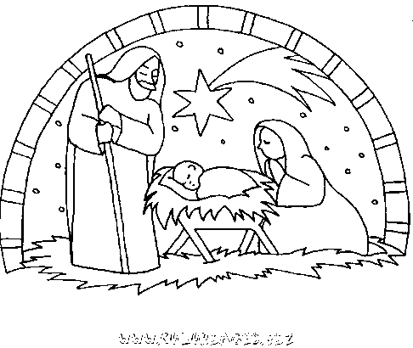](https://www.google.fr/url?sa=i&rct=j&q=&esrc=s&source=images&cd=&cad=rja&uact=8&ved=0ahUKEwjo183k9d7XAhWJKMAKHXKfB1cQjRwIBw&url=https://www.coloriages.biz/imprimer-coloriage-9402-les-amis-de-la-creche-de-noel.html&psig=AOvVaw0oNPWx4usS5VlaZflp_vvc&ust=1511877642893077)